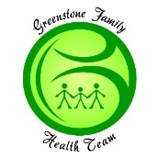

Dear Greenstone Residents,
Thank you for your patience and please continue to bear with us during this complicated, evolving and everchanging time. The Medical Clinic and the Greenstone Family Health Team remain open; however, we are asking that patients CALL and NOT come to the building. We are adhering to the social distancing guidelines set out by Public Health. Our goal is to contain the spread of the virus. All medical appointments will be by phone, indefinitely. You will receive a call from one of our receptionists to notify you of this change. During your appointment, if your provider determines you require an in-person assessment, you will be asked to come to the clinic. Also, we are experiencing staffing shortages due to self-isolation and other circumstances, we are not always able to take your call. Please continue to call and/or leave us a message. We will try to assist you the best we can. We are asking the public to please be responsible and follow social distancing and self-isolation guidelines. Please rely on evidence-based information and refer to the public health website for up to date and reliable information. https://www.ontario.ca/page/2019-novel-coronavirus-covid-19

Shannon Kristjanson
Executive Director
Greenstone Family Health Team / Geraldton Medical Clinic

